
Indus International School, Bangalore
Homework Worksheet

Grade: 11 Homework – RCA1
Subject: English A Language and Literature (HW2)
Submission Date: 17th of September, 2019
Max Marks 20

ANALYSIS OF A Photograph

Instructions:
Read the basic strategies in analysing photographs
http://nuovo.com/southern-images/analyses.html
http://tiaphotographyalevel.blogspot.com/2015/12/photo-analysis-as-a2.html

Choose any photograph related to war and answer the questions given below

Paste your photograph below:
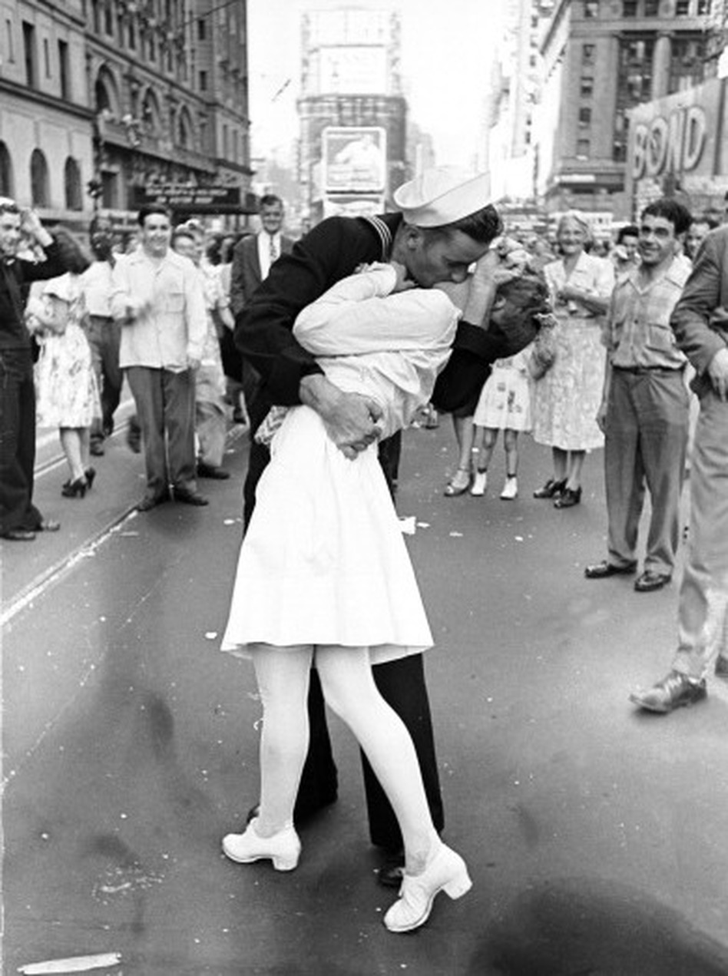

- State who took the photograph, when it was taken and the title of the image. ? [1]
The V-J day in times square, was taken by Alfred Eisenstaedt on August 14, 1945.
- Explain the context in which the photograph was taken. (Period, place, situation) [1]
The photograph was taken in times square, New York. On that day, thousands of people all over the world took to the streets to celebrate the surrender of Japan, and the end of World War II. The sailor in the photograph had a few drinks prior to the picture and he had grabbed her by “instinct” and kissed her.
- What are the thematic concerns of the photograph? [1]
The themes of this photograph include joy, mystery and glory. Joy is one of the most evident themes as it is clearly seen on the faces of by passers and also because the picture is of a U.S. Navy sailor and a nurse kissing. The photograph is mysterious due to the fact that both of their faces aren’t very and their identities weren’t known until 1980. Lastly, glory is one of the main themes of war. The happiness felt after japan surrendered comes under glory.
- What is the global issue related to the photograph?[1]
Art, creativity and imagination.

- Who is the target audience? (1)
The target audience would’ve been the U.S citizens of 1945 when it was published on the newspaper.
- Does the photo have depth of field? Explain. (1)
The photo has a large depth of field as majority of it is in focus. It’s not just the U.S. Navy sailor and the nurse that are in focus, the people behind them are also in focus.
- Does shutter speed play a role in the photograph? Explain. [1]
since the picture was taken outside during the day time indicates that there was available light and the picture is neither blurred or in sharp focus, a medium shutter speed must’ve been used. Shutter speed may not have played a big role in this photograph as the intent was to capture a brisk joyful moment not to warp or capture a rapid movement by using a slow or fast shutter speed.
- What sort of lighting has been used? What is the resulting effect? (1)
The photographer most likely used natural available light. It’s a black and white picture so the effect of it is not exactly known but from what is seen, the lighting isn’t too harsh. Though, there is a large contrast in light and colour between the sailor and the nurse and together they form a unified pillar amongst a busy street.
- What is the view point used in the photograph? How does the angle affect the theme? [1]
The photo is taken at a 90 degree angle. This angle affects the theme of joy and and glory because if it was taken at a worms point of view or birds point of view, the expression on everybody’s faces wouldn’t be visible which would discard the themes of joy and glory.

- Comment on the composition of the photograph and explain the effect (6)
- Is the photograph a landscape or portrait format?
The photograph is in a portrait format.
- Is the subject in the foreground, middle-ground or the background?
The subject is in the foreground.
- Does the subject dominate the photograph?
Yes.
- Is there a rule of thirds? Have the horizons or objects been placed a third of the way down either horizontally or vertically?
There is no rule of thirds.

- Has the Golden Ratio been observed?
It has not.
- Are there leading lines into the subject?
The straight road could be considered as a leading line.
- Is there a vanishing point?
The rest of the crowd behind is not visible so it could be a vanishing point.
- Comment on the atmosphere: (4)
- How does the photograph make you feel?
- Is the photographer communicating a message?
- What is your response to the photograph?
- When explaining your own subjective comments, use 'I think' 'I feel' 'In my opinion' etc.

Before the context of the picture came to my knowledge, I felt happiness when I looked at the photograph. When I learned the context of the picture, I felt a bit uneasy due to the fact that he didn’t take her consent. However, if the context is ignored, this photograph suggests of romance alone and anybody would think of this man and the woman to be a couple. I think that Alfred Eisenstaedt was trying to capture and convey the glee felt by the citizens of the U.S.

